16th October 2026

Dear En. Eskandar, En. Emizan, En Azil, En Lukman and En Faiz,
Subject: Resignation from the Position of Assistant Manager, IT Business Intelligence & GIT Digital R&D
I am writing to formally tender my resignation from my position as Assistant Manager, IT Business Intelligence & GIT Digital R&D, effective 16 October 2026.
In accordance with my employment contract, I will serve my three (3) months' notice period. I remain committed to performing my duties professionally throughout this period and will ensure a smooth handover of my responsibilities.
I would like to express my sincere appreciation for the opportunities, guidance, and support that I have received during my time with the IT Department & GIT Department. I am grateful for the valuable experience and knowledge I have gained, as well as the opportunity to work alongside dedicated colleagues.
During my notice period, I will continue to carry out my responsibilities diligently, prepare the necessary documentation, and provide any assistance required to facilitate a smooth transition.
Thank you once again for the opportunity to be part of the team. I wish you, the IT Department, GIT Department and the Bank continued success in the future.

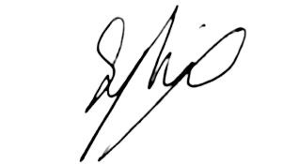
Yours sincerely,

Muhammad Syahid Bin Abd Halid
1019
Assistant Manager, IT Business Intelligence & GIT Digital R&D

